**CODE FOR ASSIGNMENT2:**

**package** TestNG;

**import** org.testng.annotations.Test;

**public** **class** NewTest3 {

@Test(groups="Gmail")

**public** **void** login()

{

System.***out***.println("login- And in Gmail Group");

}

@Test(groups="Gmail")

**public** **void** logout(){

System.***out***.println(" logout- And in Gmail Group");

}

@Test(groups="Editing")

**public** **void** compose(){

System.***out***.println("compose - And Editing Group");

}

}

**CODE FOR XML FILE:**

<?xml version="1.0" encoding="UTF-8"?>

<!DOCTYPE suite SYSTEM "http://testng.org/testng-1.0.dtd" >

<suite name="Sample Suite">

<test name="testing">

<groups>

<run>

<include name="Gmail"/>

</run>

</groups>

<classes>

<class name="TestNG.NewTest3" />

</classes>

</test>

</suite>

**OUTPUT:**

**@Test(groups="Editing")**

**public void compose(){**

**System.*out*.println("compose - And Editing Group");**

**}**

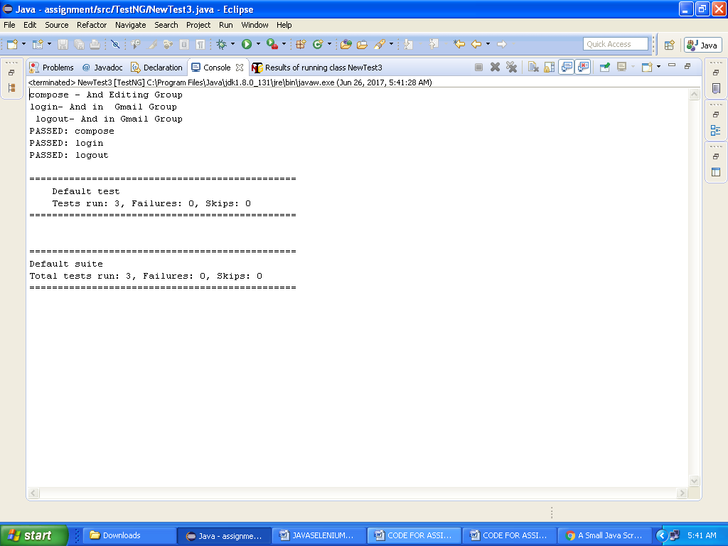

**Output for**

**@Test(enabled=false)**

**public void compose(){**

**System.*out*.println("compose - And Editing Group");**

**}**

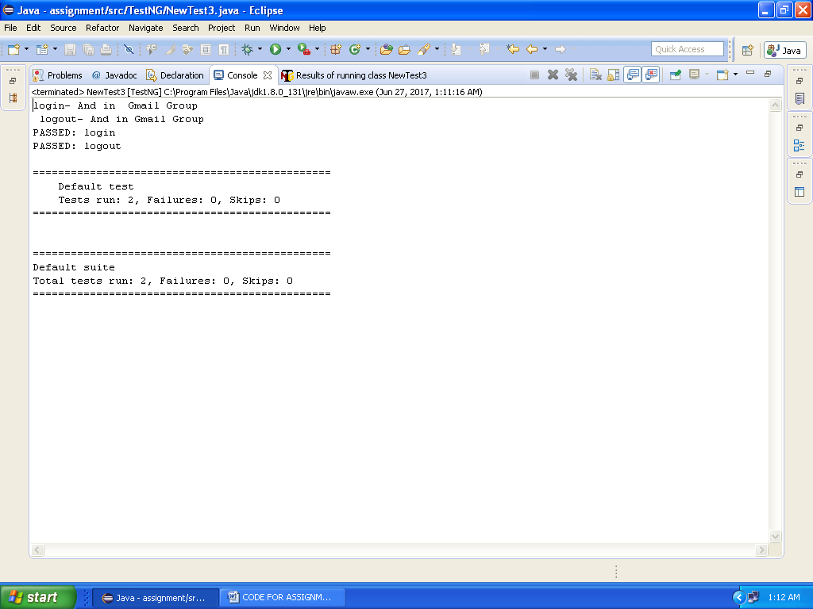

**Test Output:**

